**Pig - I**

**Student Name: Nabh Sanjay Mehta Student Id:NSM190002**

**Date: 03/12/2020**

Part-1: Setup: In this section we will setup the necessary data files for this assignment.

Step-1: Start the Cloudera VM and then launch the “terminal” application.

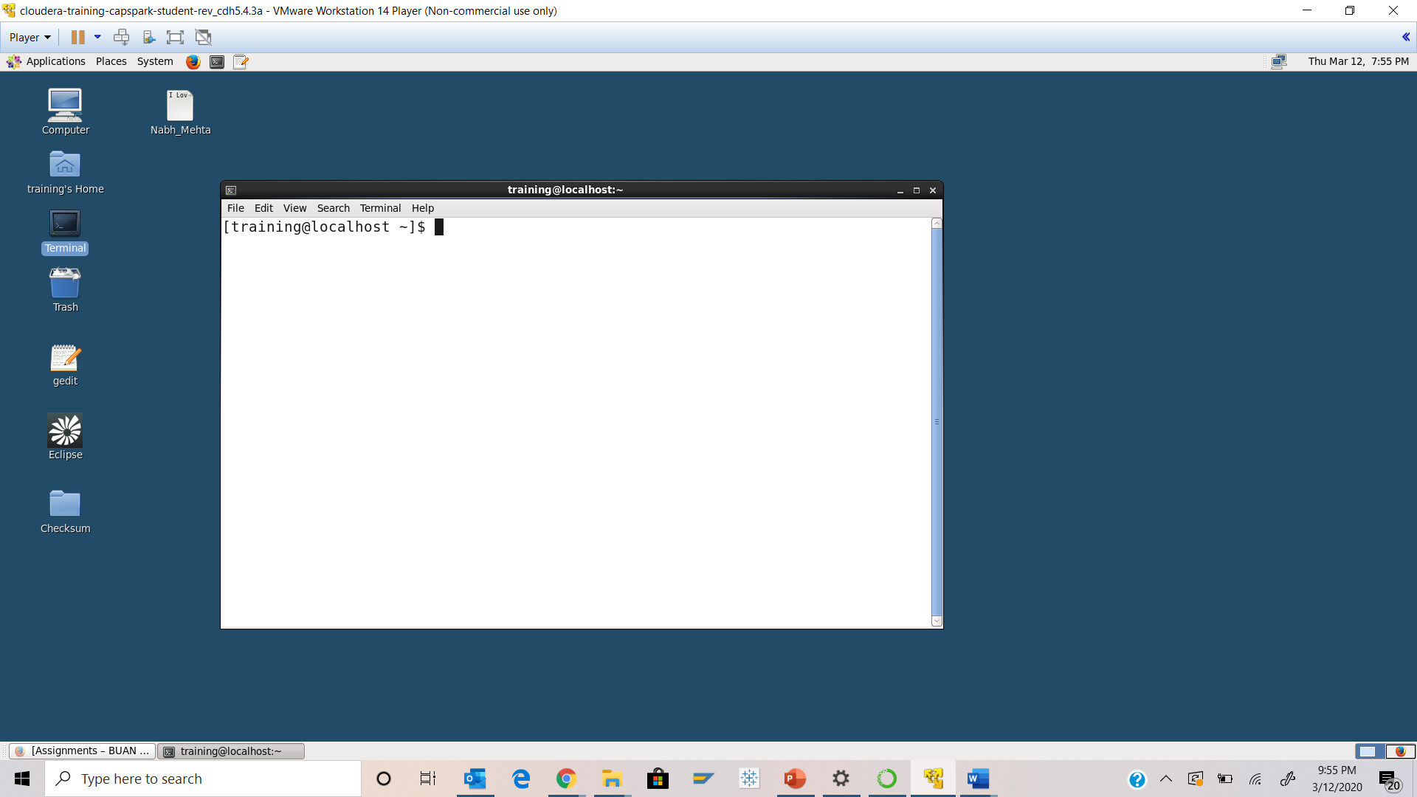

Step-2: Download the Police_Incidents.zip file from eLearning in to the downloads folder IN the Cloudera VM using Mozilla Firefox.

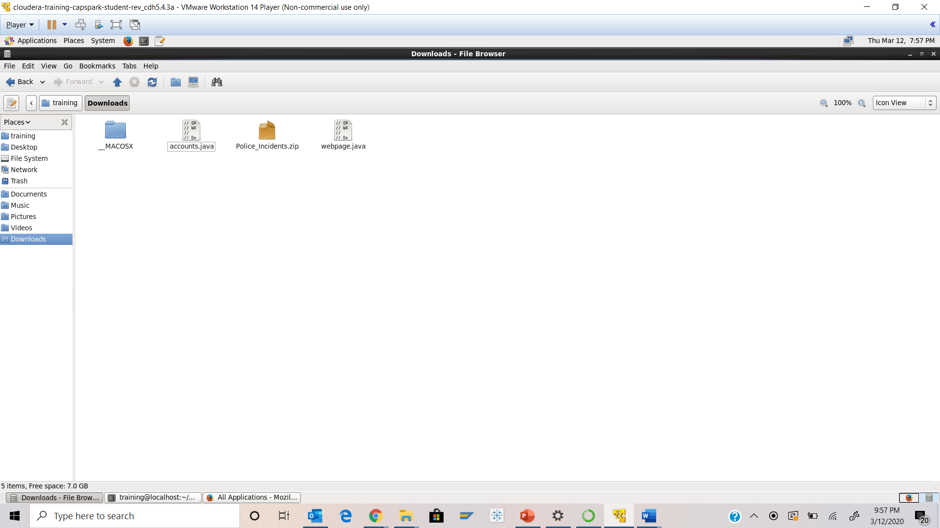

Step-3: Execute the following command:





Q. Now type the command and execute. Take a screenshot of the shell output, highlight the zip file and paste it below.

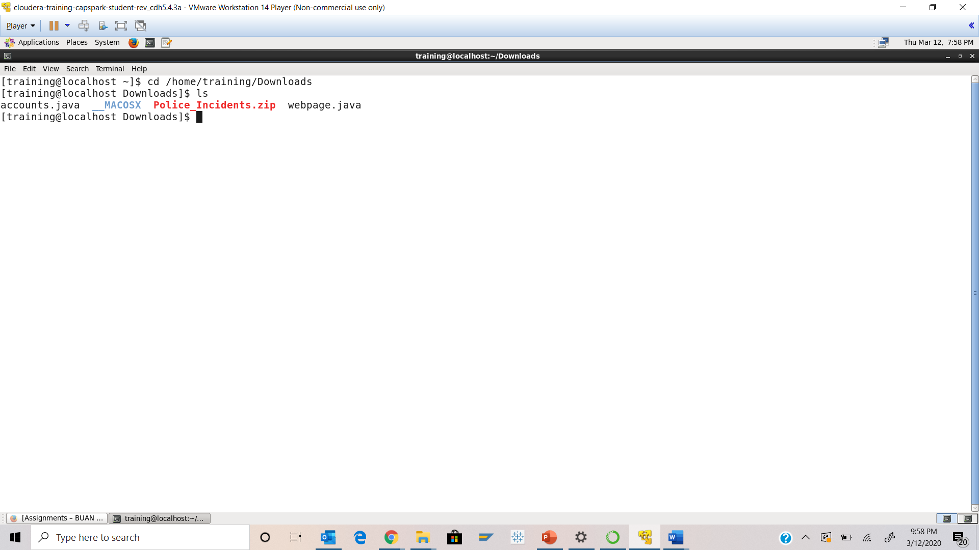



Step-4: Execute the following command at the shell prompt:





Q. Now type the command and execute. Take a screenshot of the shell output, highlight the contents of the zip file and paste it below.

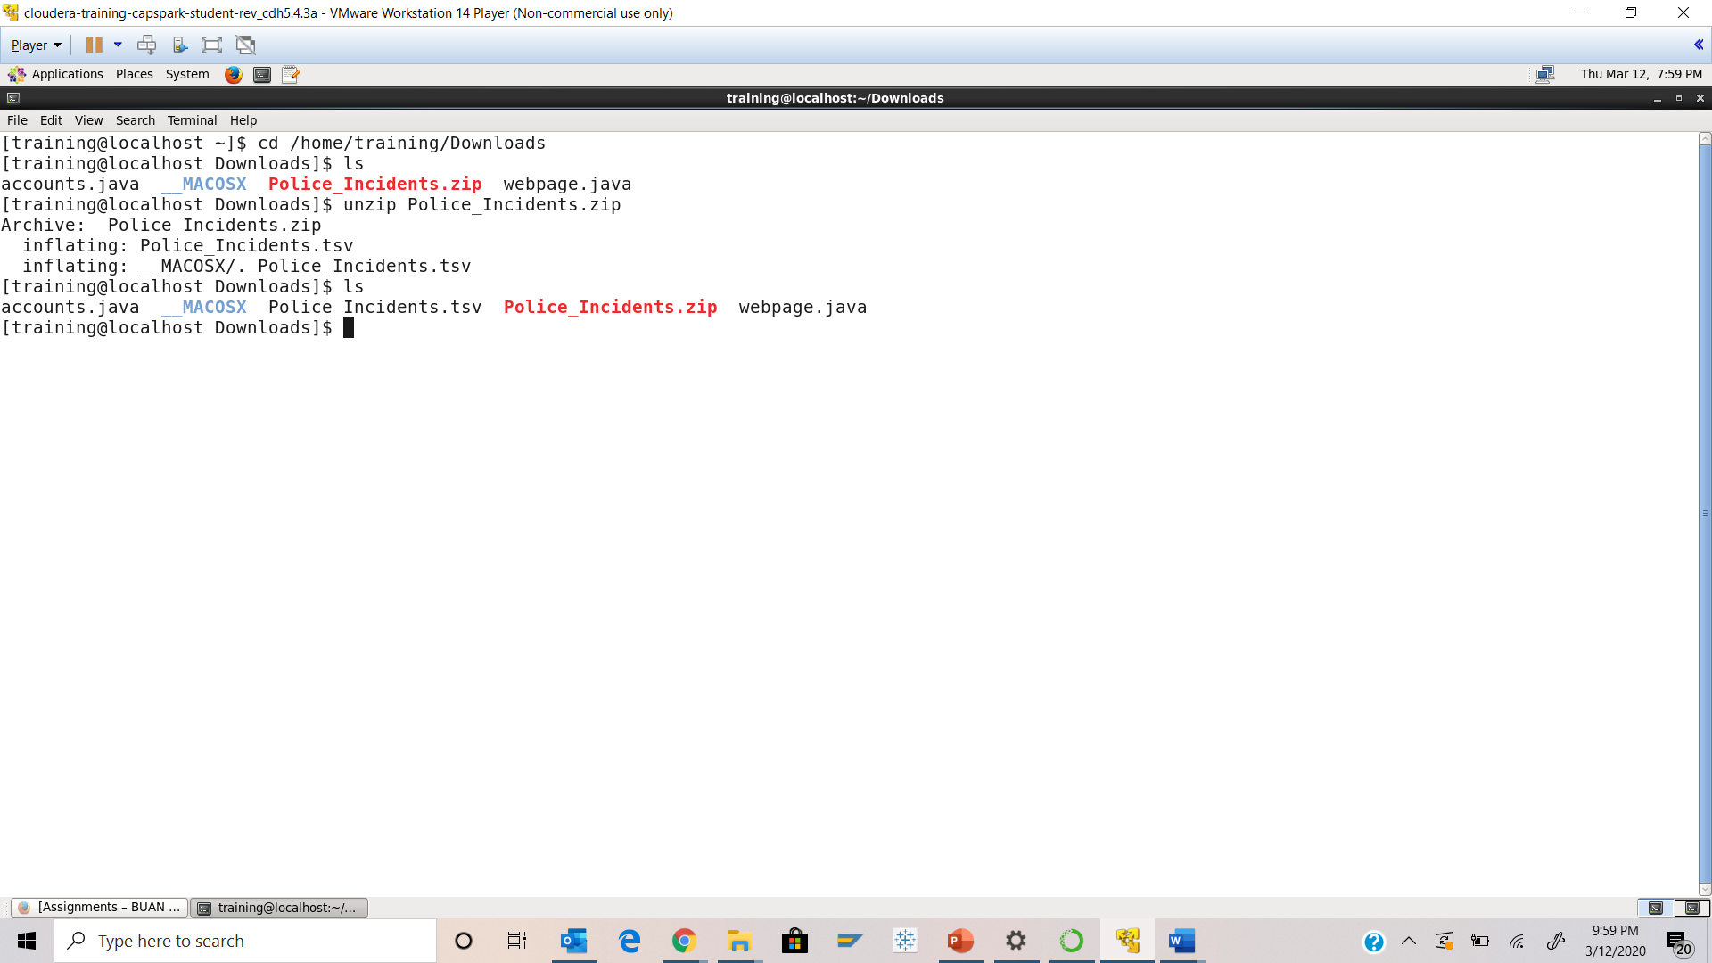



Step-5: Execute the following command at the shell prompt



Step-6: Execute the following command at the shell prompt:





Q. Now type the command and execute. Take a screenshot of the shell output and paste it below.

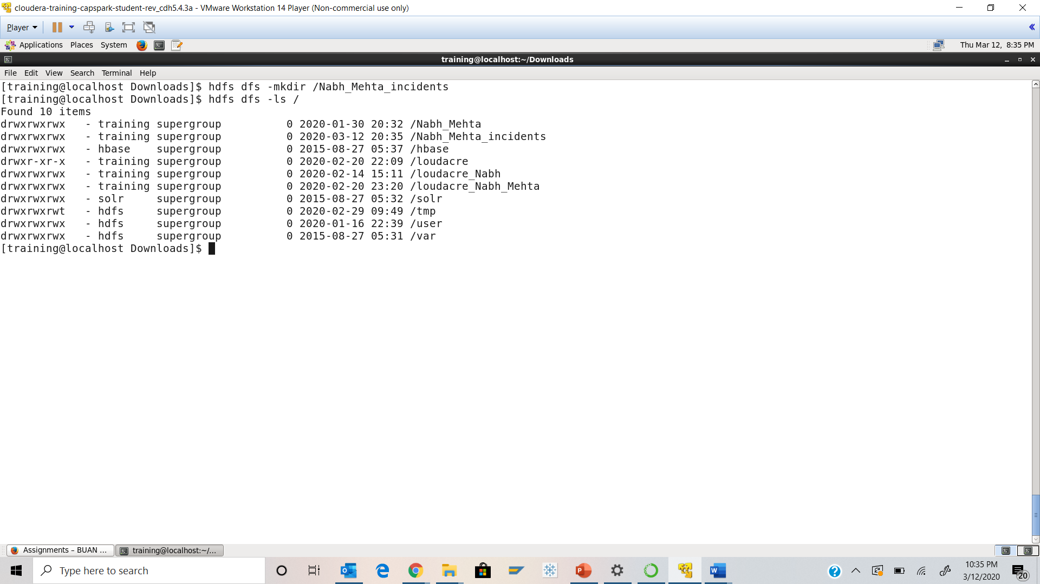

Step-7: Execute the following command at the shell prompt:



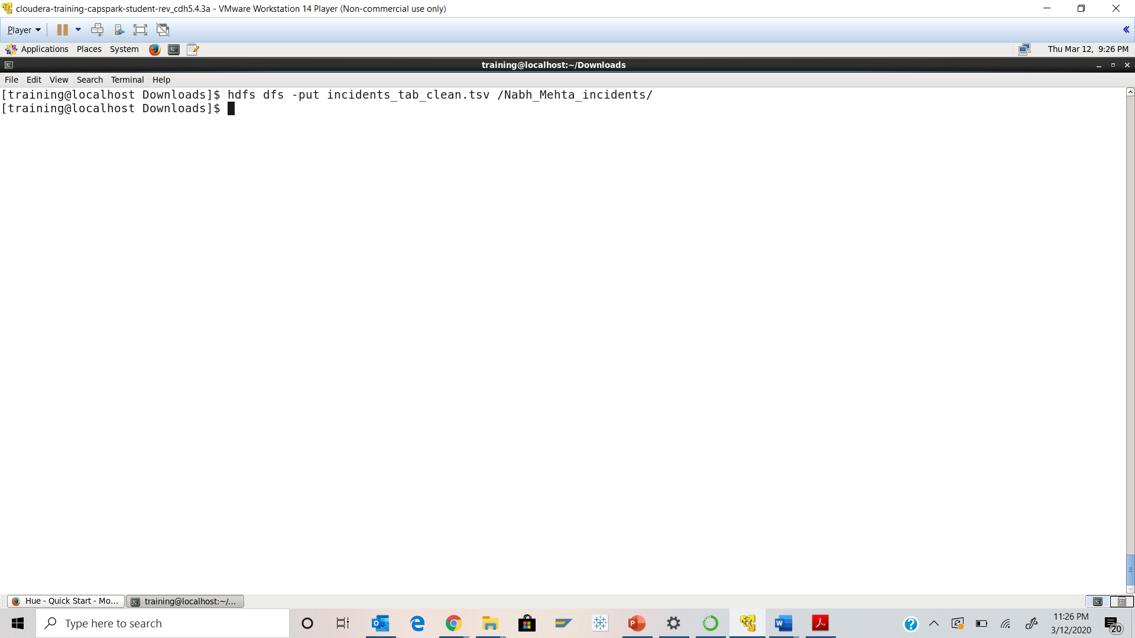

Step-8: Open the “Mozilla Firefox” browser that is located at the top of the screen. Click on the bookmark called “HUE”

Q. Take a screenshot of the HUE splash screen and paste it below.

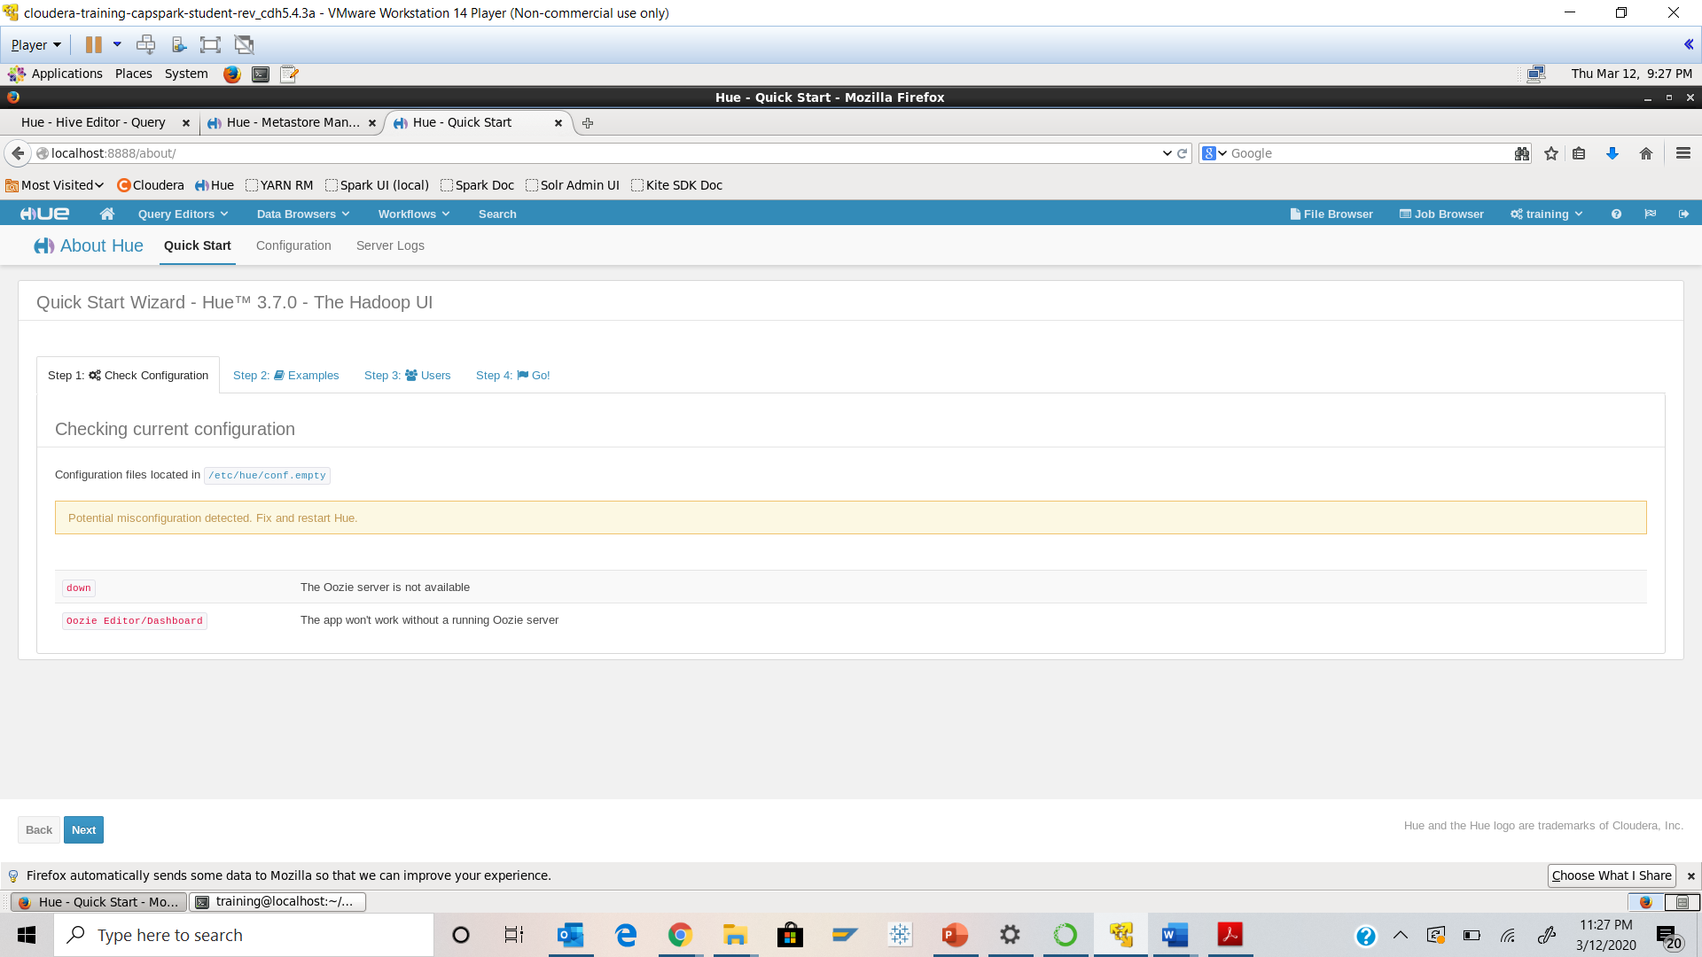

Step-9: In “HUE” browse to the directory that we created above in Step 6

Q. Take a screenshot of the directory and highlight the file that we copied.

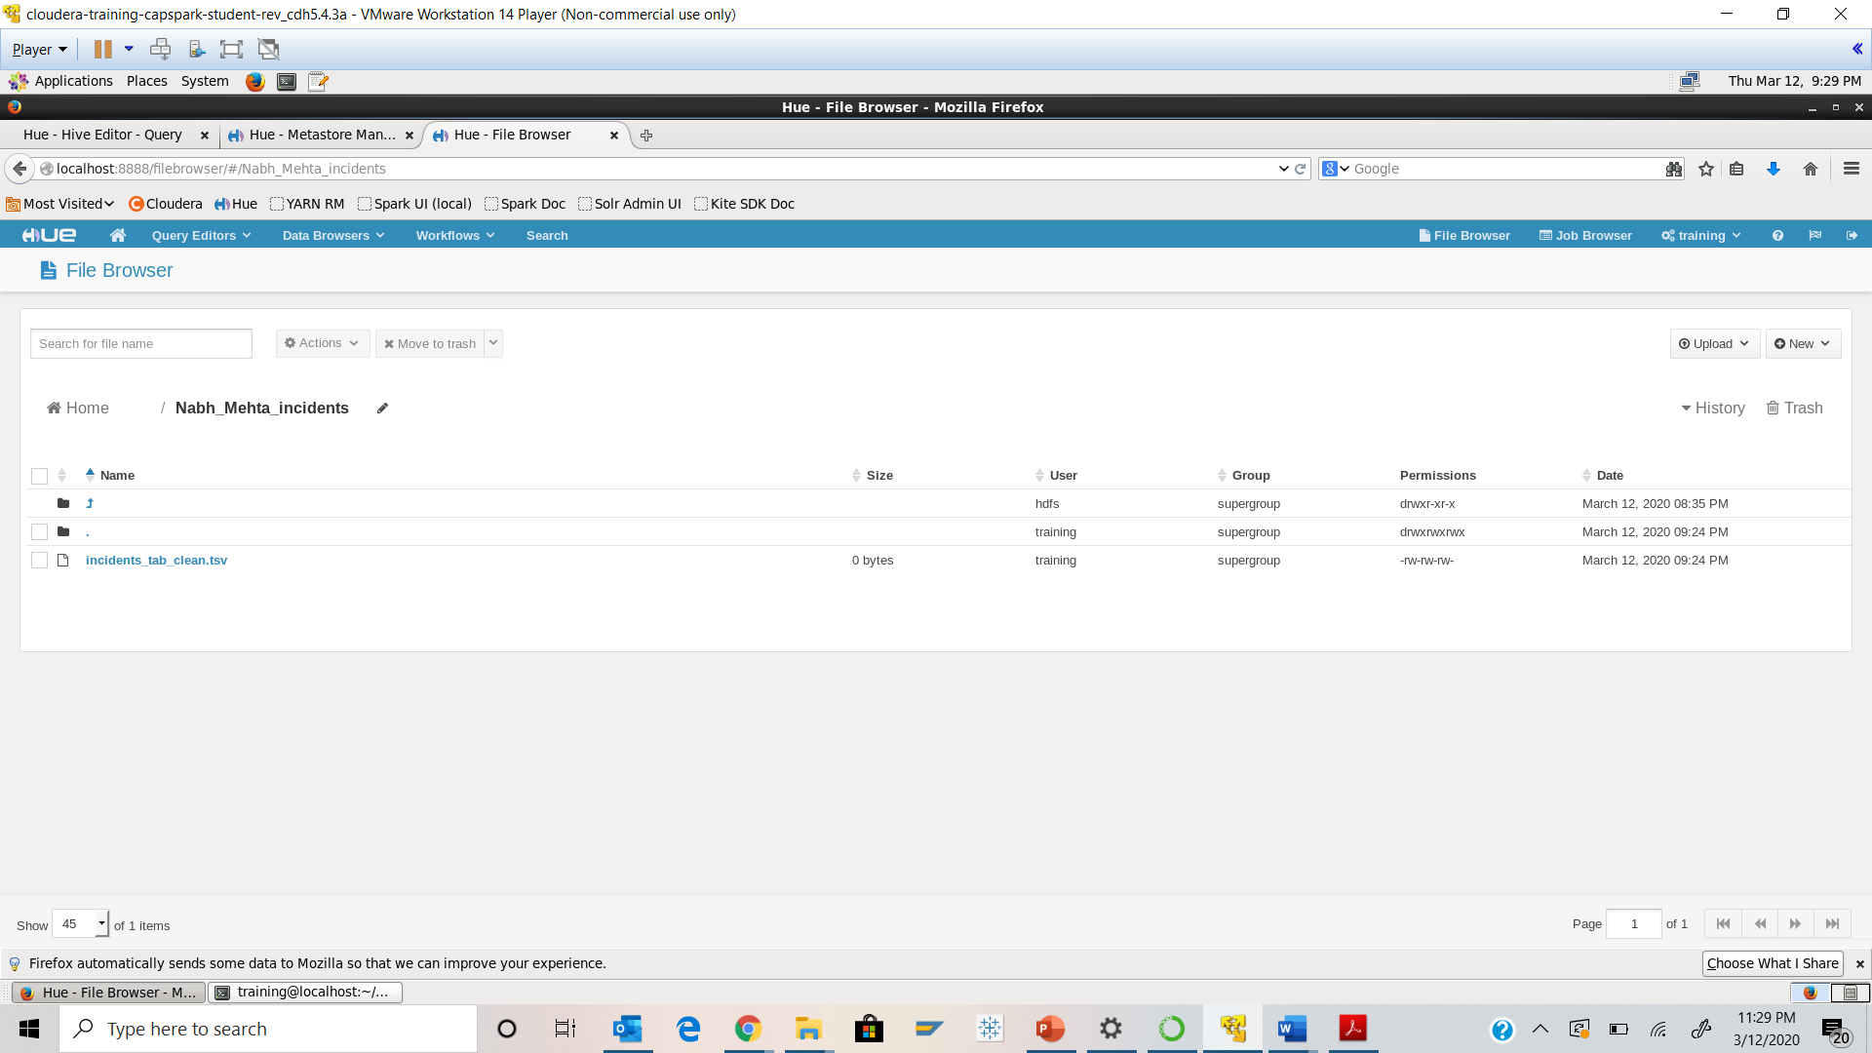



Step-9: Launch the grunt shell



Q. Take a screenshot of the shell output and paste it below.

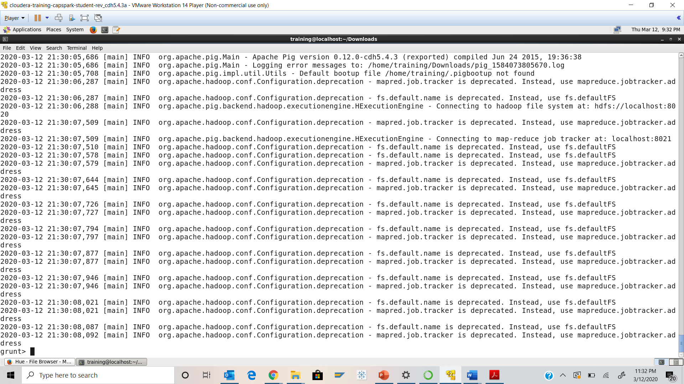

Step-10: Execute the following 4 commands at the shell prompt. Hit <enter> after each command

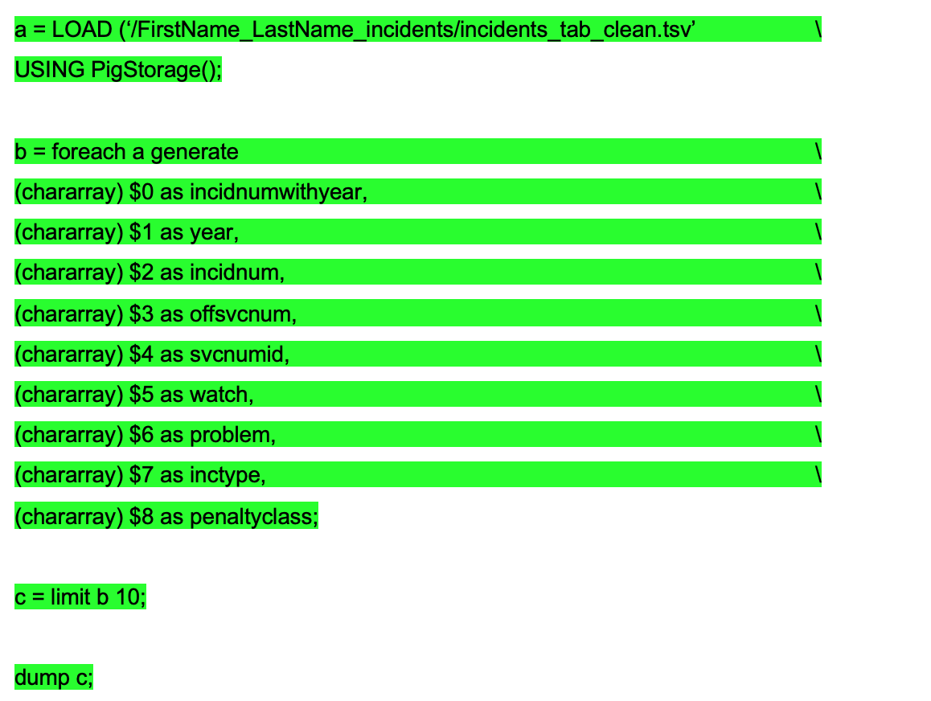

Q. Paste a screenshot of the shell output below.

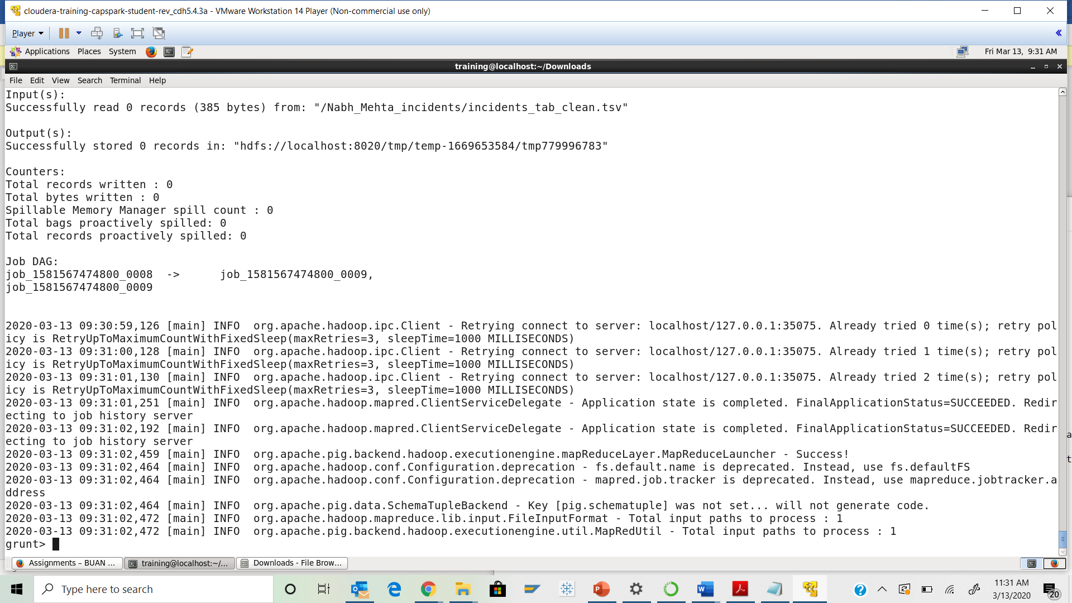

Step-11: Download the Checksum.zip file from eLearning in to the downloads folder **IN** the Cloudera VM using Mozilla Firefox.

Step-12: Execute the following command:



Q9. Now type the command and execute. Take a screenshot of the shell output, highlight the zip file and paste it below.

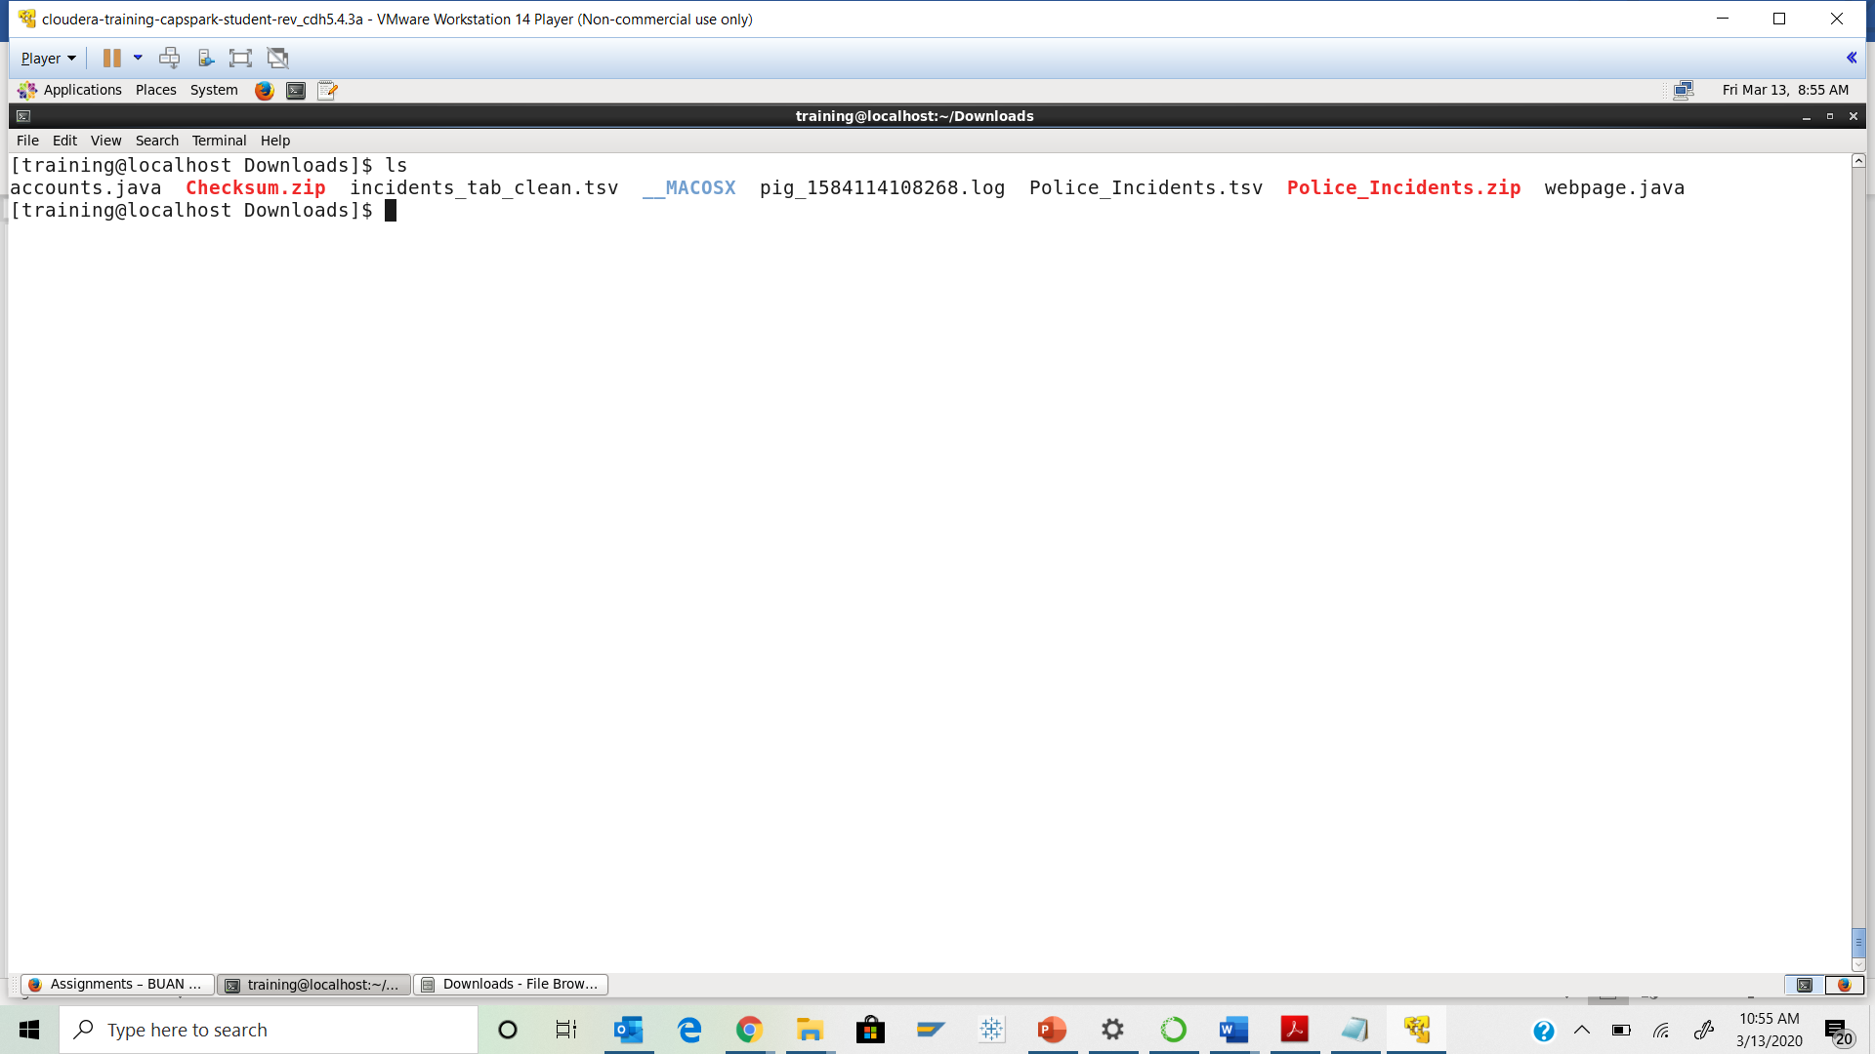



Step-13: Execute the following command at the shell prompt:



Q10. Now type the command and execute. Take a screenshot of the shell output, highlight the contents of the zip file and paste it below.

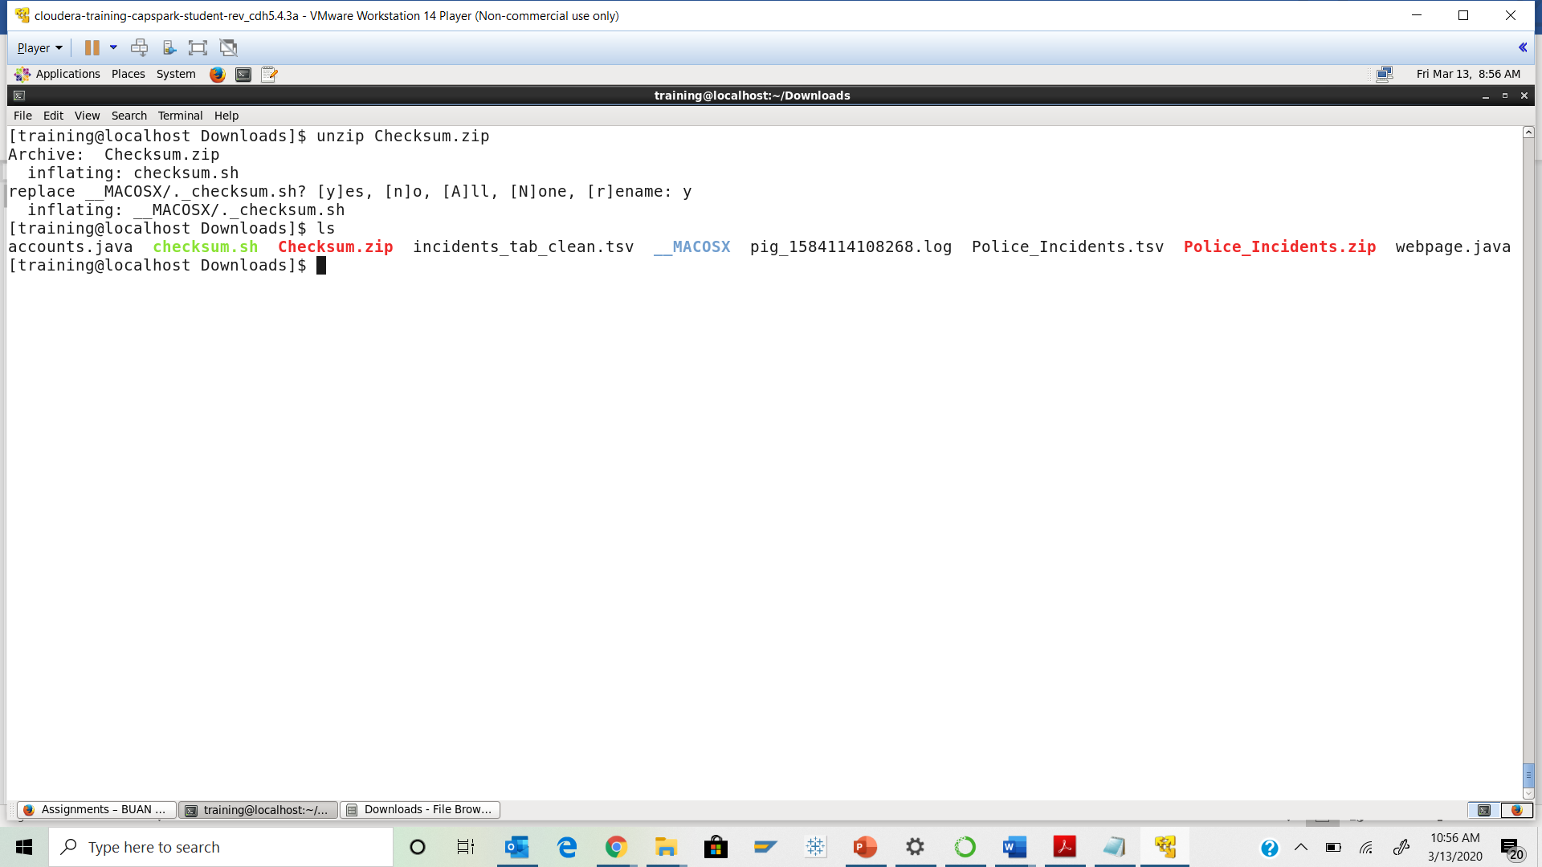



Step-14: Execute the following command at the shell prompt:

Then execute the following command:

Q11. Take a screenshot of the shell output and paste it below.

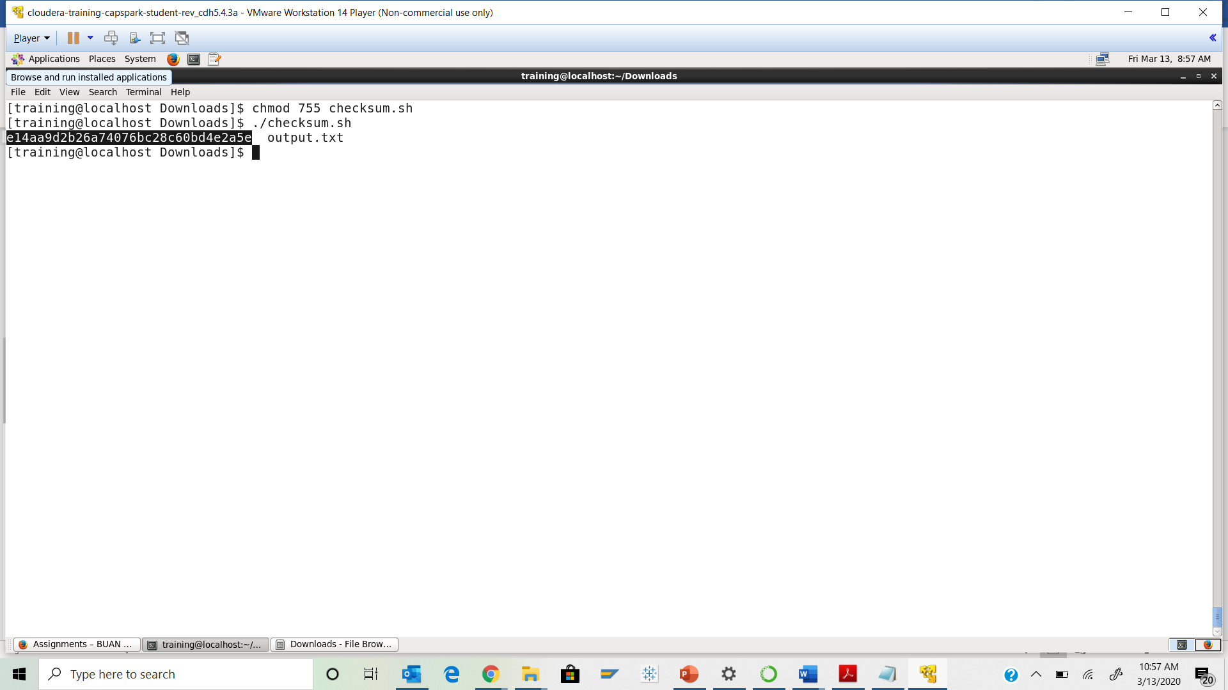Step-15: Execute the following command at the shell prompt:

rm Checksum.zip checksum.sh output.txt



Q12. Now type the command and execute. Take a screenshot of the shell output and paste it below.

